Dear Parents and Caregivers,
As part of our commitment to student learning at Yandelora School we like to pass onto information that comes to our attention that could benefit their children. We still suggest you take the time to talk through with your child’s therapists before any purchase of software and associated hardware.
Assistive Ware Apps – Discount for Autism Awareness Month
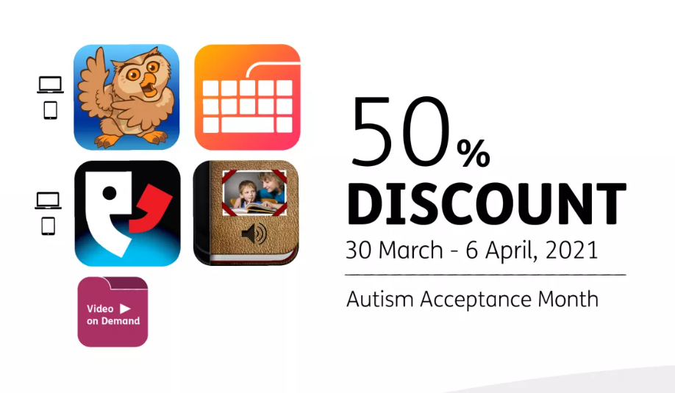
Take 50% of the regular price for Proloquo2Go, the Gateway vocabulary, Proloquo4Text, Keeble, and Pictello on iOS
These are also available for Volume Purchase Holders

Take 50% Off LAMP Words For Life
^{Posted Mar 2, 2021 - 11:22am}
Communication at Home Made Easier with 50% Off LAMP Words for Life® iOS App

For Autism Acceptance Month, we’re putting our industry-leading LAMP Words for Life® iOS app on sale again, April 2-8!
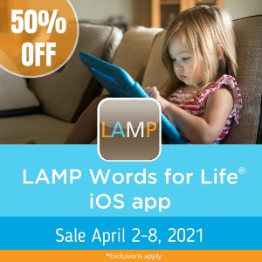
LAMP Words For Life is a robust augmentative and alternative communication (AAC) language app that combines the power of the PRC Unity® language system with Language Acquisition through Motor Planning (LAMP™) principles and strategies.
LAMP is a therapeutic approach based on neurological and motor learning principles as well as clinical experiences that address the language development and communication needs of children with autism and other developmental disabilities. It provides a consistent motor pattern for words and a systematic way to develop communication skills allowing for unlimited language growth opportunities.
The LAMP Words for Life app offers the ability to grow from an emerging vocabulabulary to complex communication without motor relearning along the way. English and a bilingual Spanish/English vocabulary are available.

Sale Terms and Conditions
- Excludes all in-app purchases.
- PRC-Saltillo will not process purchase orders for the sale.
- Exact prices may vary in other countries.
- Must be purchased via the App Store.
- Sale subject to change at any time.
- Can be combined with Apple’s Volume Purchase Program for Education discount​

