and Cake Stall
Raising funds for Yandelora School in Narellan
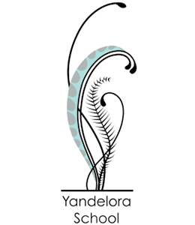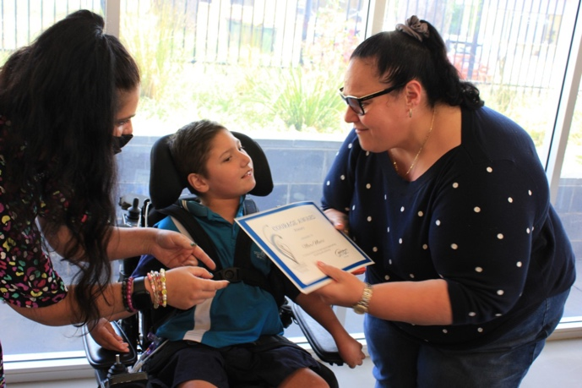

Bunnings Narellan
Saturday 11th March 2023
8am – 4pm
Come along and buy a sausage, drink and cake to support our amazing school.

