Presentation Day

Tuesday 28th of November
2023
9:30am to 11:00am

Order of Events
9:30am Presentation Day Commences

Acknowledgement to Country
Principal Address – Jacquie Lockyer
National Anthem
Yandelora School Song – Signed by Samantha Lee-Robinson
Block F Performance –Class Frog, Fur Seals and Fairy Wrens

5C Awards
We Connect – Primary & Secondary
We Create – Creative Arts Primary & Secondary
We Create – STEM Primary & Secondary
We are Courageous – Primary & Secondary
We Celebrate – Primary & Secondary
We are a Community – Primary & Secondary

2023 School Captain and Prefects – Presented by Jacquie Lockyer
Year 12 Graduates
Yandelora School 5C Award
Premier Sporting Challenge Awards
Year in Review 2023
Closing Address – Aaron Gardener

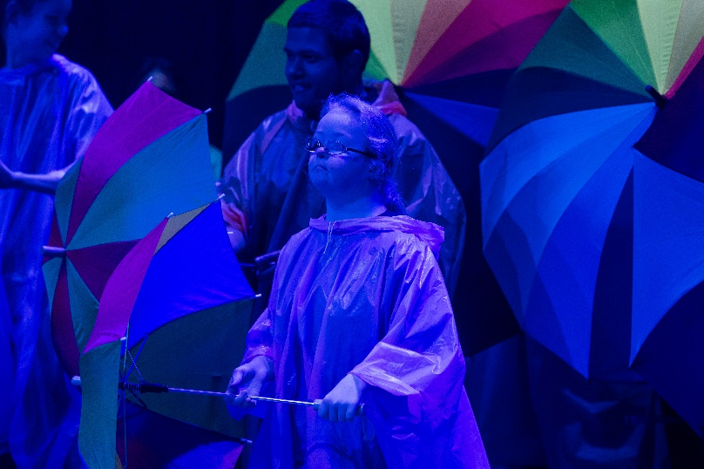
Safety Information
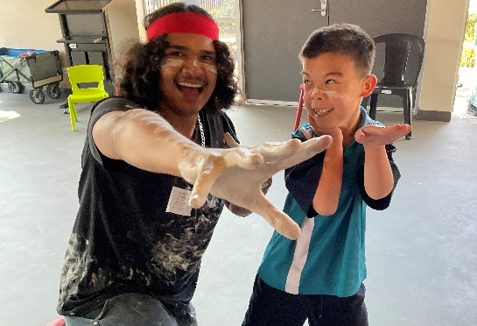
At the conclusion of today’s proceedings there will be a 5-minute period where our gates will be closed to ensure the safety of our students transitioning back to their classes. Please be mindful of this and ensure if you need to leave urgently you seek out a staff member to assist you prior to or after this safety precaution.

Taking your child home
If you are taking your child home after the event you need to please take your child to the front office to be marked as leaving. Staff have been requested to direct parents to the front office for any children leaving after the event.

Lyrebird Café
We would like to invite all our parents, families, community members and dignitaries to remain after the conclusion of the Presentation Day and access coffee, tea, and light snacks from the Yandelora School Lyrebird Café. Students from our high school hospitality program will be on hand to serve you over near the school library.

We thank all the students, staff and Yandelora School for making 2023 such a successful year and look forward to another successful year in 2024.

Thank you for your support

2023

