Dear Parents and Caregivers,

Skoolbag is a vital communication application that we use to keep you informed about the activities, events and updates within the school. If you have not yet installed this application onto your smartphone then it is highly recommended you do so as soon as possible. There is no cost to you as a user at all and is completely free. Please follow the simple instructions below to begin downloading the application to your smartphone or tablet today.

As a school we use the application SeeSaw to promote and support our students in communicating the learning they do, this application was not intended in its design for communication of events, notices and important information regarding Yandelora School as a whole. For this reason, we are transitioning to Skoolbag for all whole school communication and relying less on SeeSaw to communicate events and notices. Skoolbag also provides the facilities to submit queries to the office so that follow ups can be made effectively and quickly.

Please follow the steps below if you have not already downloaded the Skoolbag application today

Kind Regards

Aaron Gardener – Deputy Principal
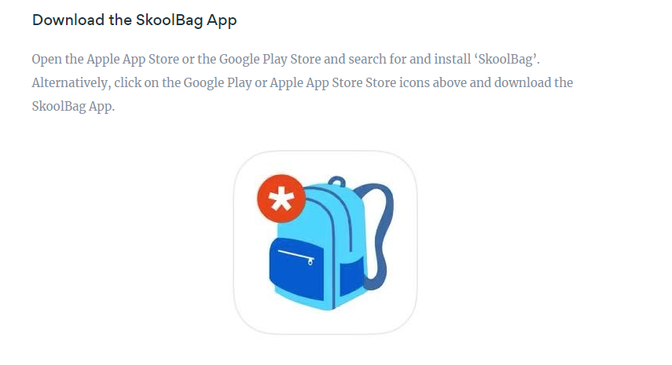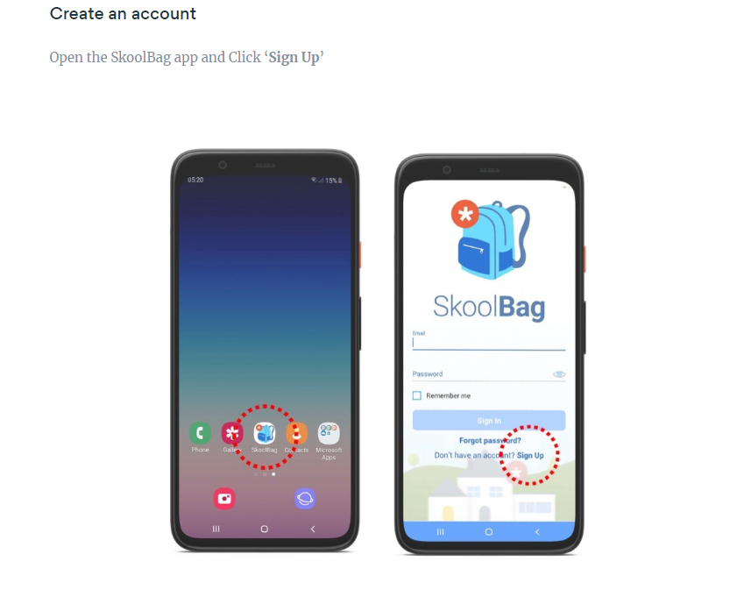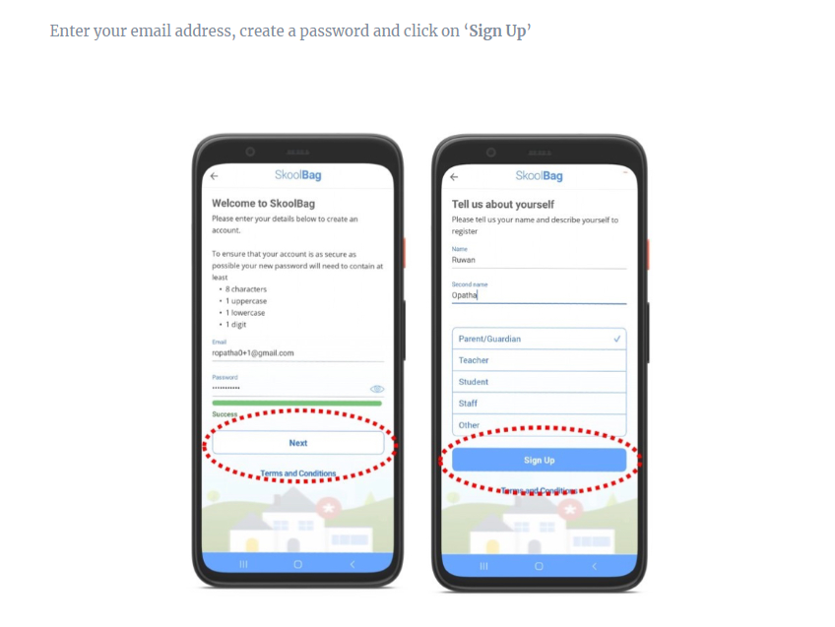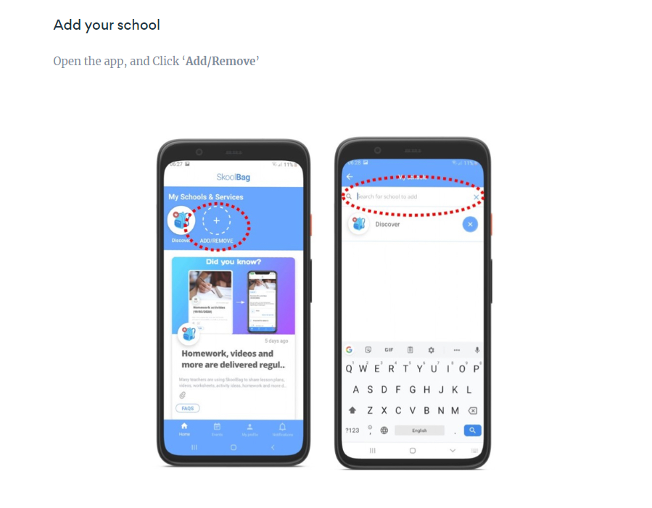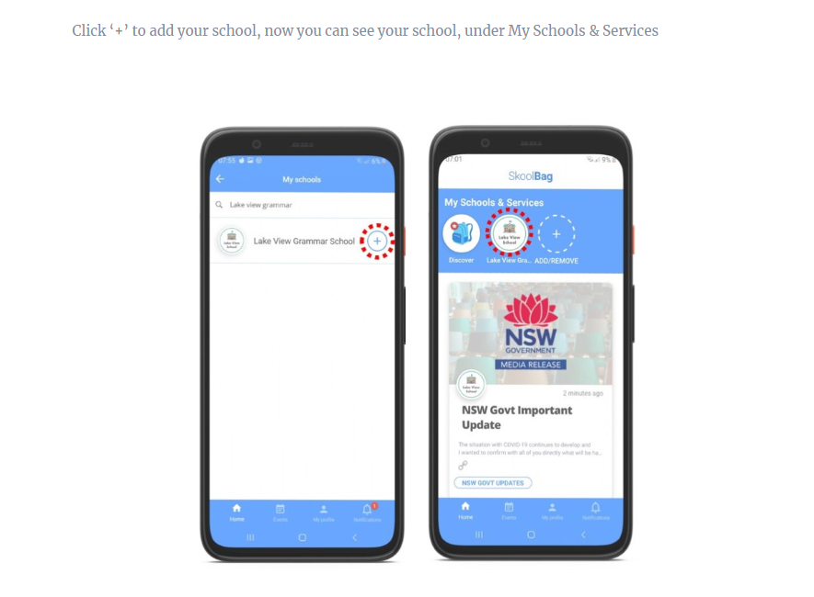

Now you have successfully completed the installation of Skoolbag to your smartphone or tablet

